# Sensitivity test on the mesh of SWLES

We did a systematic test on the mesh for SWLES with three additional SWLES cases, namely, SWLES-z, SWLES-xy, and SWLES-xyz. SWLES-z was obtained by cutting the spanwise grid number of SWLES in half. SWLES-xy was obtained by cutting the cross-sectional grid number of SWLES in half. SWLES-xyz was obtained by cutting both the spanwise and cross-sectional grid numbers in half.

Table 1 shows the mesh parameters in the cross-sectional plane of three additional SWLES and the original SWLES. The spanwise resolution is shown in Table 2. The cross-sectional mesh for SWLES is shown in Figure 1 for convenience of the understanding the mesh parameters. The detailed description of the parameters is given in the paper.

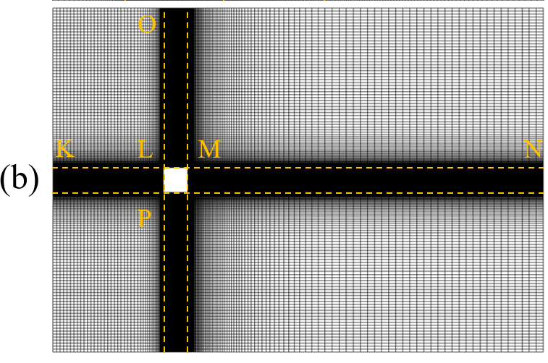

Figure 1 The cross-sectional mesh for SWLES.

Table 1 Parameters in the cross-sectional plane for SWLES and SWLES-xy. SP and EP are the starting and ending point, where the grid spacing is Δmin and Δmax, respectively. *N* is the node number. The parameters of SWLES-z and SWLES are the same. So are those of SWLES-xy and SWLES-xyz.

|  |  |  |  |  |  |  |  |  |  |
| --- | --- | --- | --- | --- | --- | --- | --- | --- | --- |
| case | Edge | SP | EP | length/*D* | Δmin+ | ratio | layer | Δmax+ | *N* |
| SWLES | KL | L | K | 4.5 | 12.5 | 1.12 | 24 | 180 | 49 |
| SWLES-xy | KL | L | K | 4.5 | 17.7 | 1.12 | 35 | 338 | 35 |
| SWLES | MN | M | N | 14.5 | 12.5 | 1.05 | 70 | 358 | 101 |
| SWLES-xy | MN | M | N | 14.5 | 17.7 | 1.064 | 50 | 525 | 80 |
| SWLES | LO | L | O | 6.5 | 12.5 | 1.06 | 44 | 150 | 82 |
| SWLES-xy | LO | L | O | 6.5 | 17.7 | 1.066 | 44 | 275 | 59 |
| SWLES | LM | L, M | -- | 1 | 12.5 | 1.05 | 11 | 23.4 | 63 |
| SWLES-xy | LM | L, M | -- | 1 | 17.7 | 1.05 | 11 | 32.5 | 47 |
| SWLES | LP | L, P | -- | 1 | 12.5 | 1.05 | 11 | 23.4 | 63 |
| SWLES-xy | LP | L, P | -- | 1 | 17.7 | 1.05 | 11 | 32.5 | 47 |

Table 2 shows the aerodynamics of four SWLES and reference data, i.e. the experimental data and DNS data. The drag coefficients (*CD*) of SWLES are close to each other, which indicates *CD* is relatively intensive to the mesh resolution. The drag fluctuations ($C_{D}^{rms}$) of these SWLES do not show a clear dependency on the spanwise mesh resolution (Δ*z*). However, the lift fluctuations ($C_{L}^{rms}$), *St,* and *Lr* are sensitive to Δ*z*. These three quantities are close when Δ*z* is the same, such as SWLES and SWLES-xy, SWLES-z and SWLES-xyz. The change of Δ*z* will lead to a notable change in these three quantities*,* such as SWLES and SWLES-z. Besides, these three quantities will deviate from the results of WRLES if the Δ*z* of SWLES is low.

Table 2 The spanwise mesh resolutions of the four SWLES and aerodynamics of the four SWLES, WRLES experimental data, and DNS. *Nz* and Δz+ are the spanwise grid number and mesh resolution. *N_cell* is the total cell number. *CD* is the time-averaged drag coefficient. $C_{D}^{rms}$ and $C_{L}^{rms}$ are the root mean square (r.m.s.) drag and lift coefficients, respectively. *St* represents the Strouhal number. *Lr* is the formation length.

|  |  |  |  |  |  |  |  |  |
| --- | --- | --- | --- | --- | --- | --- | --- | --- |
| Case | *Nz* | Δz+ | *N_cell* | *CD* |  |  | *St* | *Lr* |
| Experiment (Lyn et al., 1995) | -- | -- | -- | 2.11 | -- | -- | 0.132±0.004 | 1.38 |
| DNS (Trias et al., 2015) | -- | -- | -- | 2.18 | 0.205 | 1.71 | 0.132 | 1.04 |
| WRLES | -- | -- | -- | 2.288 | 0.136 | 1.423 | 0.139 | 1.165 |
| SWLES | 61 | 82 | 2.6 × 106 | 2.265 | 0.135 | 1.345 | 0.139 | 1.240 |
| SWLES-z | 31 | 167 | 1.3 × 106 | 2.234 | 0.131 | 1.248 | 0.133 | 1.357 |
| SWLES-xy | 61 | 82 | 1.4 × 106 | 2.245 | 0.118 | 1.350 | 0.139 | 1.260 |
| SWLES-xyz | 31 | 167 | 0.7 × 106 | 2.215 | 0.154 | 1.287 | 0.133 | 1.331 |

Figure 2 shows the time-averaged surface pressure coefficients (*Cp*) of SWLES and WRLES. Overall, the *Cp* is not very sensitive to variation in the mesh. The *Cp* of SWLES-xy was very close to that of SWLES, while those of SWLES-z and SWLES-xyz deviated slightly from that of SWLES. This may indicate the spanwise mesh resolution has more influence on the *Cp* than the cross-sectional resolution.

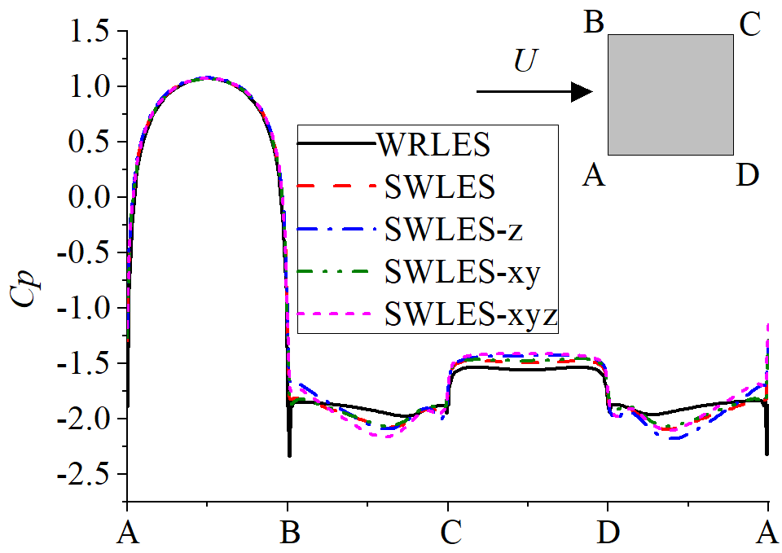

Figure 2 Distributions of the time-averaged surface pressure coefficient *Cp.*

Figure 3 shows the velocity profiles along the wake centerline. The mean streamwise velocity <*u>* is shown in Figure 3(a). The four SWLES show a similarprofile. If looking closer, we can observe that four SWLES profiles can be divided into two groups according to Δ*z*, similar to the results of $C_{L}^{rms}$, *St,* and *Lr*. Figure 3(b) shows the profiles of streamwise velocity fluctuations *σu*. All profiles of four SWLES collapse in the very near wake, *x*/*D*<1.5. More downstream (1.5<*x*/*D*<3), the *σu* profiles can also be divided into two groups like the results of <*u>*. In the far wake (*x*/*D*>3), the discrepancy becomes clear in each group. Maybe, this is the result of the different cross-sectional resolutions. Figure 3(c) is the profile of the transverse velocity fluctuations *σv*. Again, the spanwise mesh resolution predominates the results.

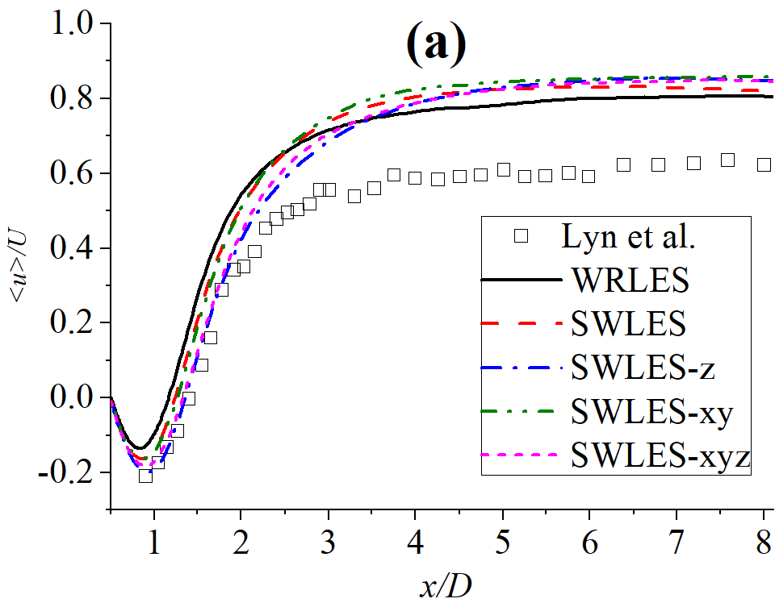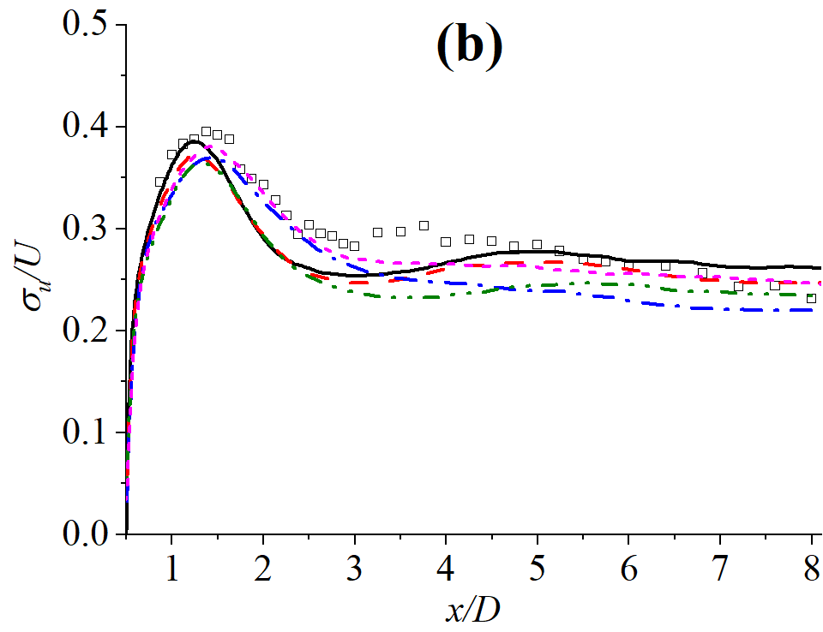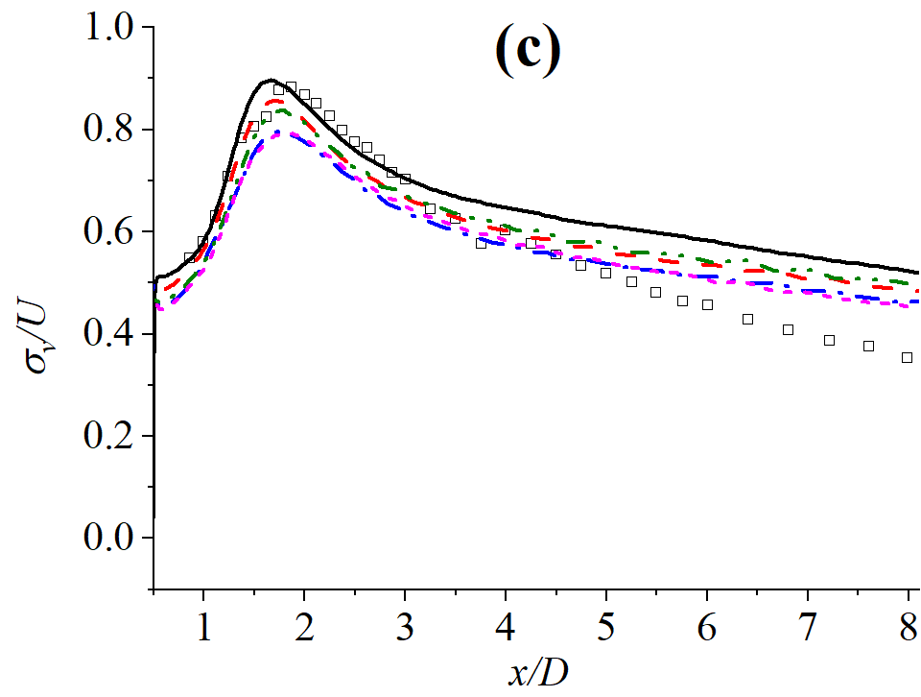

Figure 3 Velocity profiles along the wake centerline: (a) mean streamwise velocity <*u>*, (b) streamwise velocity fluctuations *σu*, and (c) transverse velocity fluctuations *σv*.

There is also something that need to be pointed out. The result of SWLES-xyz agrees best with the experimental data at some regions, i.e. the <*u>* at the near wake, *x*/*D*<2. This can be considered a numerical uncertainty. The measurement of the results of the four SWLES should be the agreement with the results of WRLES, since our objective is to achieve a similar accuracy to that of WRLES via SWLES with a much lower computational cost.

In conclusion, most of the results, including the aerodynamics ($C_{L}^{rms}$, *St,* and *Lr*), surface pressure distributions, and velocity profiles are close for the four SWLES. The spanwise mesh resolution Δ*z* has a predominant influence, while the cross-sectional resolution shows a minor influence. Among these four SWLES cases, both SWLES and SWLES-xy achieve a similar result to WRLES since they have a finer spanwise resolution than the other two SWLES. The results of SWLES are slightly better than that of SWLES-xy, because the $C_{D}^{rms}$ of SWLES-xy is under-predicted, and the streamwise velocity fluctuation of SWLES-xy is also under-predicted in the region of the *x*/*D* > 3. Since the computational cost of SWLES is lower enough compared with WRLES for the present flow, the mesh of SWLES is suitable. However, if a lower mesh is really preferred, then the mesh size in the cross-sectional plane can be reduced like that of SWLES-xy.

# Reference

Lyn, D.A., Einav, S., Rodi, W., Park, J.H., 1995. A laser-doppler velocimetry study of ensemble-averaged characteristics of the turbulent near wake of a square cylinder. J. Fluid Mech. 304, 285-319.

Trias, F.X., Gorobets, A., Oliva, A., 2015. Turbulent flow around a square cylinder at reynolds number 22,000: a dns study. Comput. Fluids 123, 87-98.